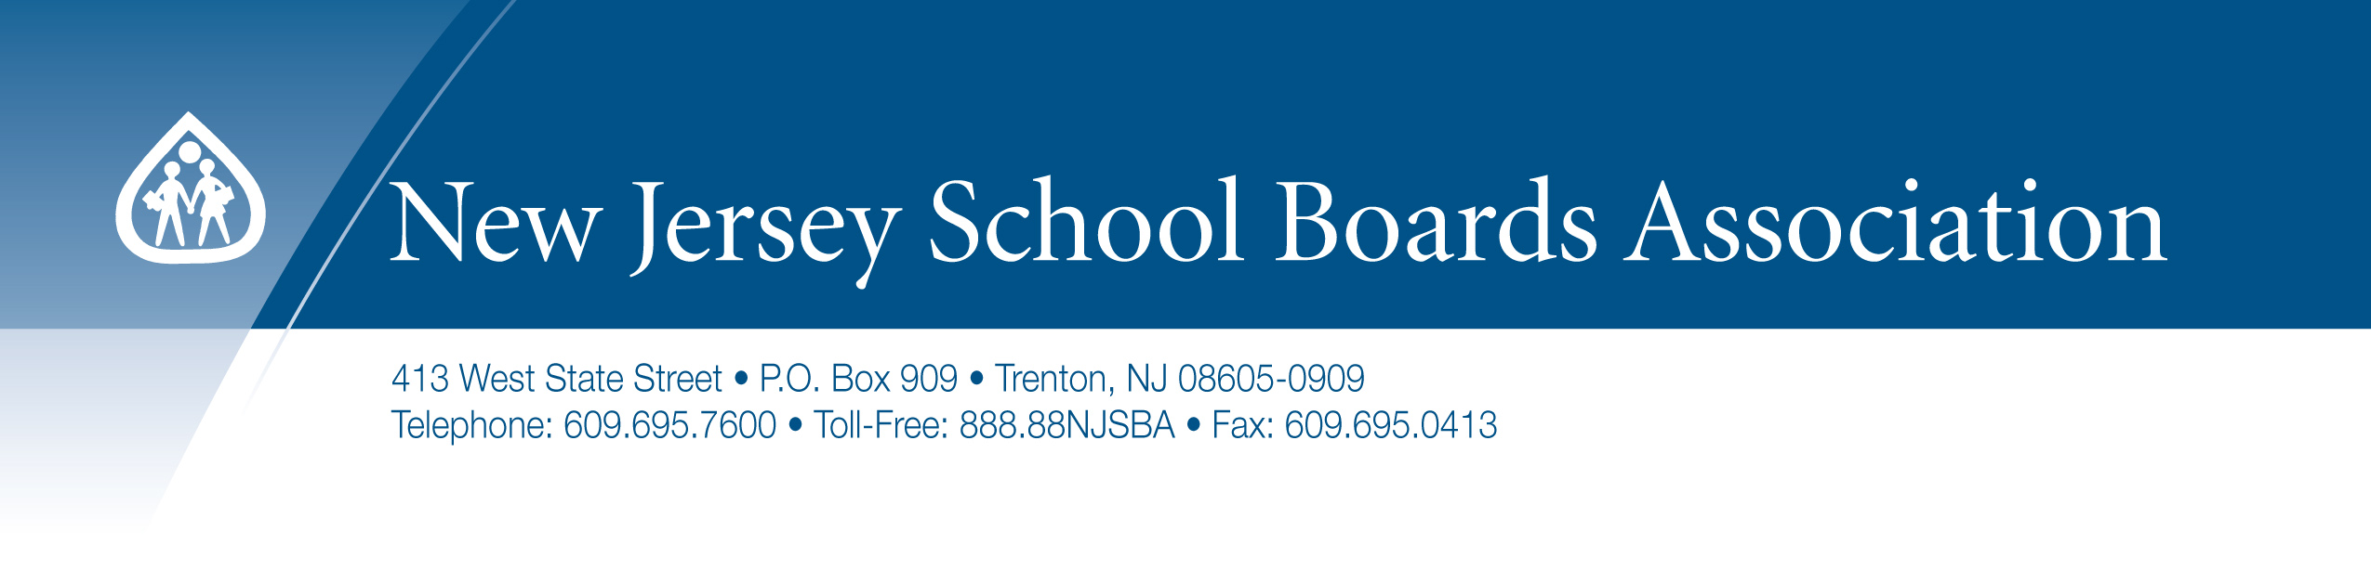

CONTRACT FOR POLICY CUSTOMIZATION

THIS AGREEMENT is made and entered into as of the date of execution, by and between Union Township Board of Education, 2369 Morris Avenue, Union, New Jersey 07083, hereinafter referred to as “district” or “board,” and the New Jersey School Boards Association (referred to herein as “NJSBA”), a body corporate and politic having its usual place of business at 413 West State Street, P.O. Box 909, Trenton, New Jersey 08605.

Definitions

For the purpose of this contract the following definitions apply:

District: Refers to the district board or the board authorized designee.

Policy manual assessment: This is the Policy Consultant’s initial assessment of the district’s current manual as provided by the district.

In consideration of the mutual promises contained herein, and other consideration, NJSBA and the district agree as follows:

- NJSBA agrees to provide the district with the services of a NJSBA policy consultant who will:

- Review existing board policies, regulations and bylaws. The review of these documents is solely for the purpose of insuring consistency and no analysis shall be provided.

- Meet and/or confer initially with the district or its designee to:

  - Mutually establish parameters for the purpose of assisting and advising the district and/or its designee during the customization process;

  - Identify and agree upon the district’s discretionary policy content to be reviewed and incorporated pursuant to this Agreement, not to exceed 150 consultant work hours in completion of the manual.

c. Review and recommend necessary revisions to all legally mandated policies.

  - Review and recommend revisions to the identified discretionary policies as agreed upon
in the initial meeting.

  - Keep the district informed about problems and policy options, and solicit district input.

f. Provide consultation, for the purpose of revision, recommendations and customizations to the district’s policy manual according to the policy manual assessment.

g. Provide the district with the final draft including one finished manual in print and CD form which shall contain at a minimum all legally mandated policies and revised identified discretionary policies. The district acknowledges that NJSBA shall retain a copy of the finished manual. The manual shall be delivered no later than six (6) months following the signing of this contract. NJSBA is not responsible for revisions, additions and/or modifications to the manual after delivery. Additional printed copies may be purchased at a cost of $100.00 per manual.

B. The district agrees that it will:

- Provide the consultant with the district’s existing policy manual, as well as other relevant material requested.

- Provide a district representative(s) that shall consult with NJSBA during the manual writing project.

- Pay a fee to NJSBA of $8,500 upon execution of this contract.

- Hold NJSBA harmless for any damages caused by any policy, contract, advice, or other consulting services rendered pursuant to this agreement.

The district has until the date the finished manual is delivered or six months from the date of contract execution, whichever comes first, to contract for NJSBA’s online policy service at the discounted first year rate of $2,000.00. A separate contract for the online policy service will be executed at that time.

It is mutually agreed and understood that no alteration or variation of the terms of this agreement shall be valid unless made in writing and signed by the parties thereto, and that no oral understanding or agreements not incorporated herein, and no alterations or variation of the terms hereof, unless made in writing between the parties hereto, shall be binding.

In the event that any provision of this contract is held to be void or unenforceable by any court or regulatory authority having jurisdiction thereof, such ruling will not affect the validity of this contract; the remaining provisions shall continue to be in full force and effect.

The parties hereto represent that they have each obtained their own legal counsel in the preparation and review of this agreement. Neither party has relied upon any representations not set forth in this agreement.

This Agreement shall be governed by the laws of the State of New Jersey

IN WITNESS WHEREOF, each party has caused this Agreement to be signed and executed by a duly authorized person on the day and year first above written.

_________________________
Marie S. Bilik Raymond R. Wiss
Executive Director, NJSBA President, NJSBA

_________________________ _________________________
Date: Date:

_________________________
Board President (Sign) Board Secretary/Business Administrator (Sign)

_________________________
Board President (Print) Board Secretary/Business Administrator (Print)

_________________________ _________________________
Date: Date:

Contract-Policy-manual8500 Union Twp 12-11

